

Semester Two

Examination 2016

Question/Answer booklet

MATHEMATICS
SPECIALIST UNITS 3 & 4

Section One:
Calculator-free

Student Name: _____________________________________
Teacher’s Name: _____________________________________

Time allowed for this section
Reading time before commencing work: five minutes
Working time for paper: fifty minutes

Material required/recommended for this section

To be provided by the supervisor
This Question/Answer booklet
Formula Sheet

To be provided by the candidate
Standard items: pens (blue/black preferred), pencils (including coloured), sharpener, correction tape/fluid, erasers, ruler, highlighters

Special Items: nil

Important note to candidates
No other items may be taken into the examination room. It is your responsibility to ensure that you do not have any unauthorised notes or other items of a non-personal nature in the examination room. If you have any unauthorised material with you, hand it to the supervisor before reading any further.

Structure of this paper

 | Number of questions available | Number of questions to be attempted | Working time (minutes) | Marks available | Percentage of exam
Section One  Calculator—free | 6 | 6 | 50 | 50 | 35
Section Two  Calculator—assumed | 12 | 12 | 100 | 100 | 65
 |  |  |  |  | 100

Instructions to candidates

- The rules for the conduct of Western Australian external examinations are detailed in the
Year 12 Information Handbook 2016. Sitting this examination implies that you agree to abide by these rules.

- Answer the questions according to the following instructions.

Show all your working clearly. Your working should be in sufficient detail to allow your
answers to be checked readily and for marks to be awarded for reasoning. Incorrect answers given without supporting reasoning cannot be allocated any marks. For any question or part question worth more than two marks, valid working or justification is required to receive full marks. If you repeat an answer to any question, ensure that you cancel the answer you do not wish to have marked.

It is recommended that you do not use pencil, except in diagrams.

- You must be careful to confine your responses to the specific questions asked and to follow any instructions that are specific to a particular question.

- Spare pages are included at the end of this booklet. They can be used for planning your responses and/or as additional space if required to continue an answer.
- Planning: If you use the spare pages for planning, indicate this clearly at the top of the page.
- Continuing an answer: If you need to use the space to continue an answer, indicate in the original answer space where the answer is continued, i.e. give the page number. Fill in the number of the question that you are continuing to answer at the top of the page.

- The Formula Sheet is not handed in with your Question/Answer Booklet.

Section One: Calculator–free 35% (50 marks)

This section has six (6) questions. Attempt all questions. Write your answers in the spaces provided.
Spare pages are included at the end of this booklet. They can be used for planning your responses and/or as additional space if required to continue an answer.

Working time: 50 minutes

Question 1 (5 marks)

The graph below shows the curve $x^{2}+4y^{2}+2x=3$, and the tangent L which has been drawn at the point where the curve crosses the y axis.

Determine the exact equation of the line L. (5 marks)

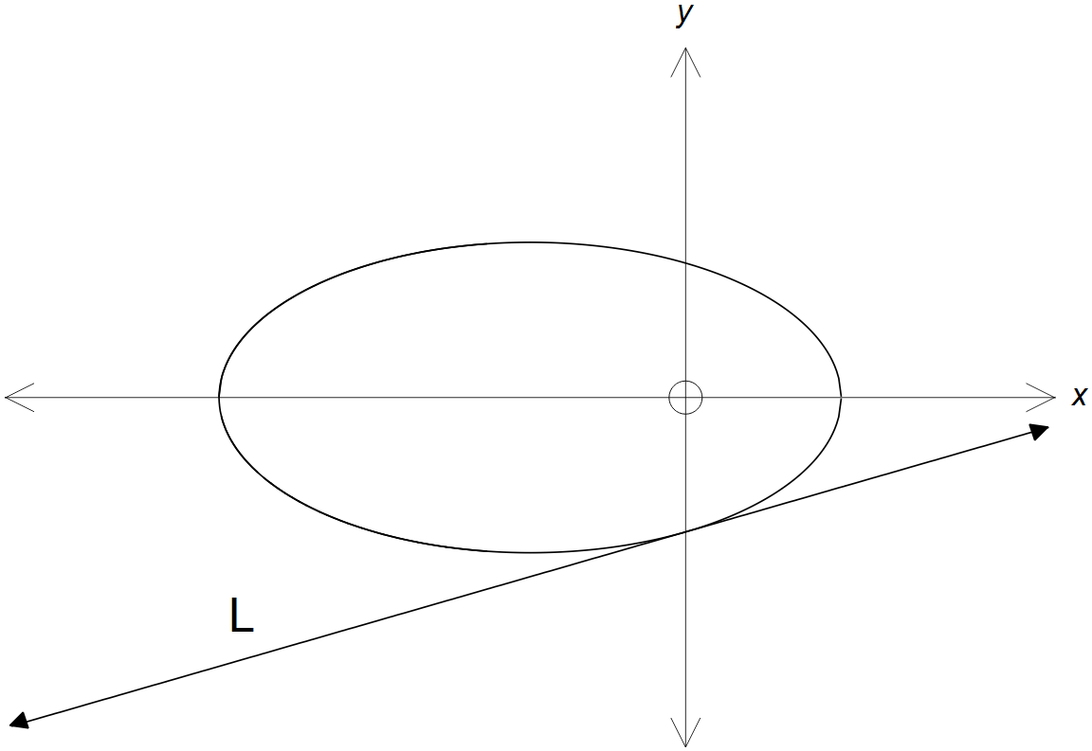

Question 2 (10 marks)

(a) Use De Moivre’s rule to evaluate ${\left(1+i\right)}^{5}+{\left(1-i\right)}^{5}$. (5 marks)

(b) State the sets that define each of the following loci.

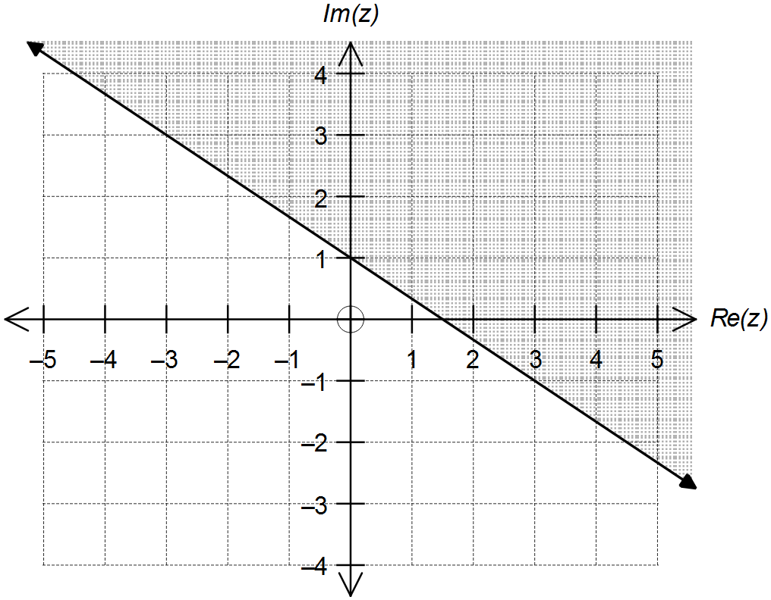 (i) (2 marks)

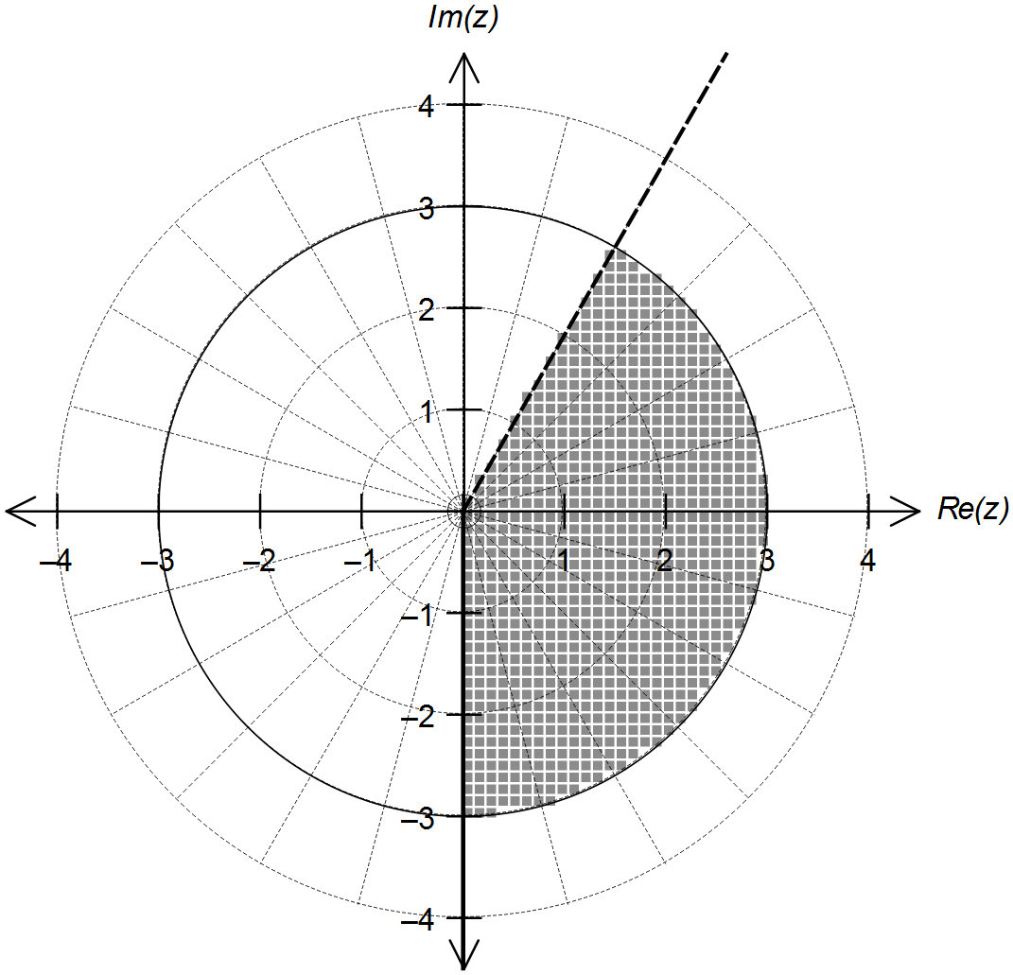
(ii) (3 marks)

Question 3 (9 marks)

(a) Determine: (4 marks)
$$\int{\cos{x}\left(1-\cos{x}\right) dx}$$

(b) Use an appropriate substitution to determine: (5 marks)

$$\int_{\frac{π}{6}}^{\frac{π}{4}}{\frac{\sin{(2x)}}{1+\cos{(2x)}} dx}$$

Question 4 (12 marks)

The function $f(x)$ is defined for $x≠0$ by: $f\left(x\right)=\frac{{2x}^{2}-3x+1}{x^{2}-x}$

(a) Use division of polynomials to express the function $f(x)$ in the format $f\left(x\right)=A+\frac{g\left(x\right)}{x^{2}-x}$
where $A∈R$ and $g(x)$ is a linear function.
(3 marks)

(b) Hence, or otherwise, sketch the graph of $f(x)$ on the axes provided below. (4 marks)

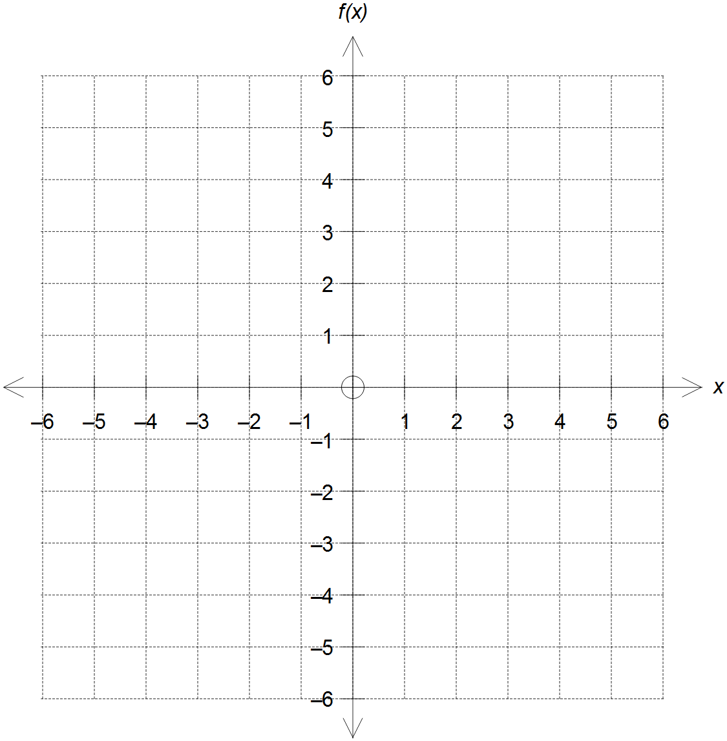

Question 4 (Continued)

(c) State the range of $f(x)$. (1 mark)

(d) Show that $f^{-1}\left(x\right)=\frac{1}{2-x}$ and state the domain of $f^{-1}(x)$. (2 marks)

(e) Sketch the graph of $f^{-1}(x)$ on the same set of axes in (b), clearly labelling all relevant
points and features.
(2 marks)

Question 5 (7 marks)

A region is bounded by the y-axis and the curves $y=\sin{x}$ and $y=\cos{x}$ as shown below.

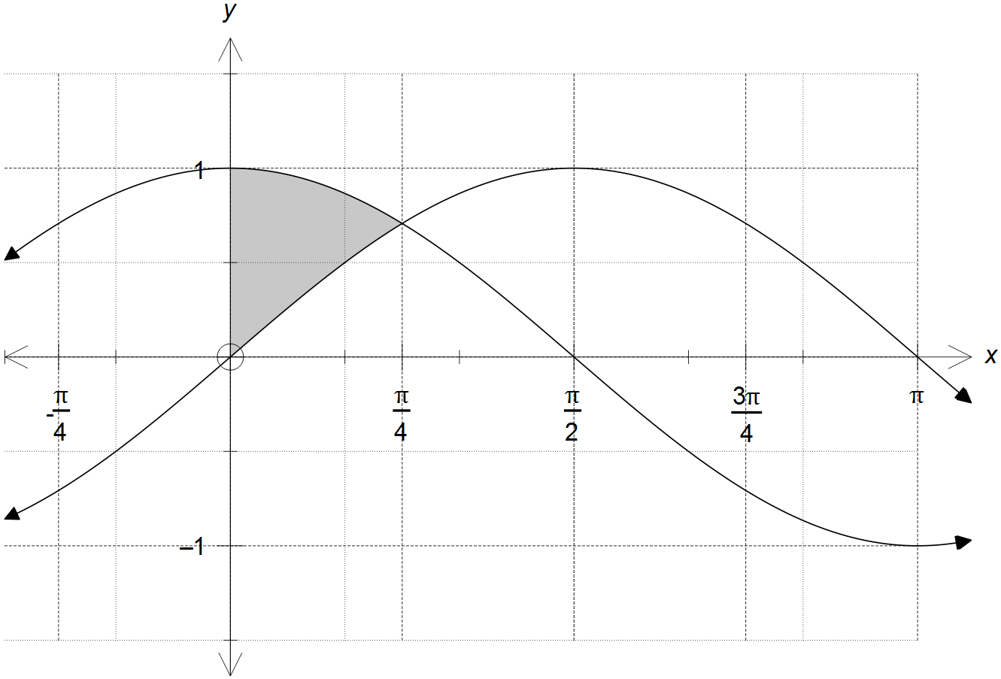

(a) Evaluate: (2 marks)
$$\int_{0}^{\frac{π}{4}}{\left(\cos{x}-\sin{x}\right)dx}$$

Question 5 (Continued)

(b) Calculate the exact volume of the solid generated by rotating the region shown in the
diagram around the x-axis.
(5 marks)

Question 6 (7 marks)

The coefficients of the system of linear simultaneous equations shown is represented by the matrix $M$, with $p,q∈R$.

$\begin{matrix}2x+y+z=1 \\ 2y+z=q-2 \\ -y-pz=10\end{matrix}$ ⇒ $M=\left[ \begin{matrix}2 & 1 & 1 \\ 0 & 2 & 1 \\ 0 & -1 & -p\end{matrix} \begin{matrix}1 \\ q-2 \\ 13\end{matrix} \right]$

(a) The matrix M can be simplified into the form shown below.
Determine $a$ and $b$ in terms of $p$ and/or $q$. (2 marks)

$$M=\left[ \begin{matrix}2 & 1 & 1 \\ 0 & 2 & 1 \\ 0 & 0 & a\end{matrix} \begin{matrix}1 \\ q-2 \\ b\end{matrix} \right]$$

(b) Determine the unique solution to the system of simultaneous linear equations for
when $p=5$ and $q=3$. (3 marks)

(c) Using your answer in (a), state the conditions on $p$ and/or $q$ so that the system of
simultaneous linear equation has:

(i) infinite solutions. (1 mark)

(ii) no solution. (1 mark)

End of Questions
Additional working space

Question number(s): ……………………

Additional working space

Question number(s): ……………………

